**Medicine Alert**

**and**

**Reminder System**

**(MARS)**

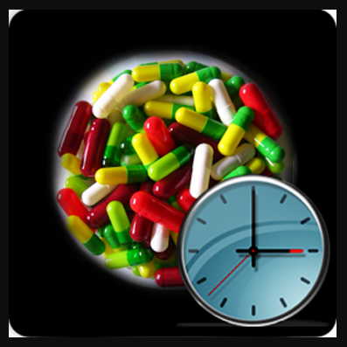

**Team Number :16**

**Team Members:**

* Paresh Sudin Kasare - 39
* Harish Kolla - 44
* Sreeya Reddy Daripalli - 18
* Ravali Nalla - 59

**Table of Contents**

**Topic Page no**

I Introduction 3

II Project Goal and Objectives 4

III First Increment Report 5

IV Implementation 11

V API 14

VI Testing 16

VII Technology Used 17

VIII Project Management 18

IX References 19

**I.Introduction**

Staying healthy and getting your medications exactly when your body needs them is vital, but sometimes you just forget. Taking your medication should be as easy and automatic as possible, not yet another thing you need to add to your mental checklist.

Phizer.com website states that 4 out of 10 adults who consume more than 1 prescribed medicine, either miss schedule or forget to take medicine completely. We believe that a system which continuously monitors or reminds the user of medicine consumption along with the dosage and directions could significantly improve effect of the medicines and in-turn help user avoid indirect losses incurred due to the mistake of skipping / forgetting medicines.

**Medicine Alert and Reminder System** is the system which provides the complete system for medicine management. It helps users to add their medicines with the recommended time and the app will remind to take medicines on specific time. If a medicine must have a minimum gap of hours, then app will remind of the next dosage of medicine after recommended gap between two dosages.

**II. Project Goal and Objectives**

**GOAL:**

To develop an application that schedules and alerts the user about the medicine to be taken.

**OBJECTIVES:**

We have following objectives for MARS system to be able to function as all-inclusive system to manage medicine schedules.

* Develop an android application which will be able to alert and record medicine consumption date, time and accordingly manage inventory.
* Develop an application which will schedule the medicines to be taken.
* Image-to-text API is used in order to take picture and detect medicine to convert it into text so that it can be used to retrieve information about the medicine.

**SYSTEM FEATURES:**

Following are the feature in our system:

* **Medicine reminder:** Add your medicines with the recommended time and App will remind you to take medicines on time. Never miss a single dose of medicines as prescribed.
* **Medicine refill reminder:** Reminds you to place refill order with your pharmacy before you run out of your daily prescribed medicines.
* **Medicine schedule manager:** If a medicine must have a minimum gap of hours then app will remind of the next dosage of medicine after recommended gap between two dosages.

**Significance:**

As per FDA.gov website, Centers for Disease Control and Prevention (CDC) estimates that non-adherence to taking medicines on time and at prescribed schedule could result in chronic disease treatment failure and in worst case it could lead to death of a person. MARS would really be helpful to avoid such circumstances which have lot of importance in user’s life.

There are applications which remind people their medicine consumption times, **MARS** has multiple functions like Medicine reminder, Medicine refill reminder, Medicine schedule manager. All these functionalities make MARS system for medicine management.

**III. First Increment Report**

**Detailed Design Features**

**Login Wireframe:**

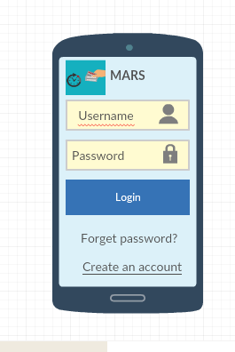

**Register Wireframe:**

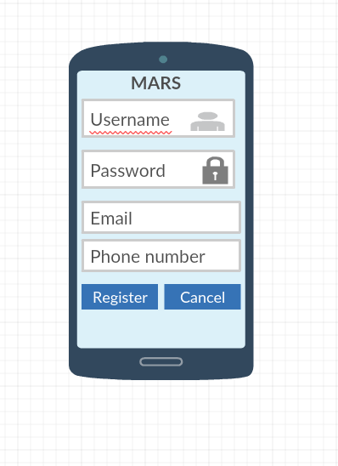

**Class Diagram:**

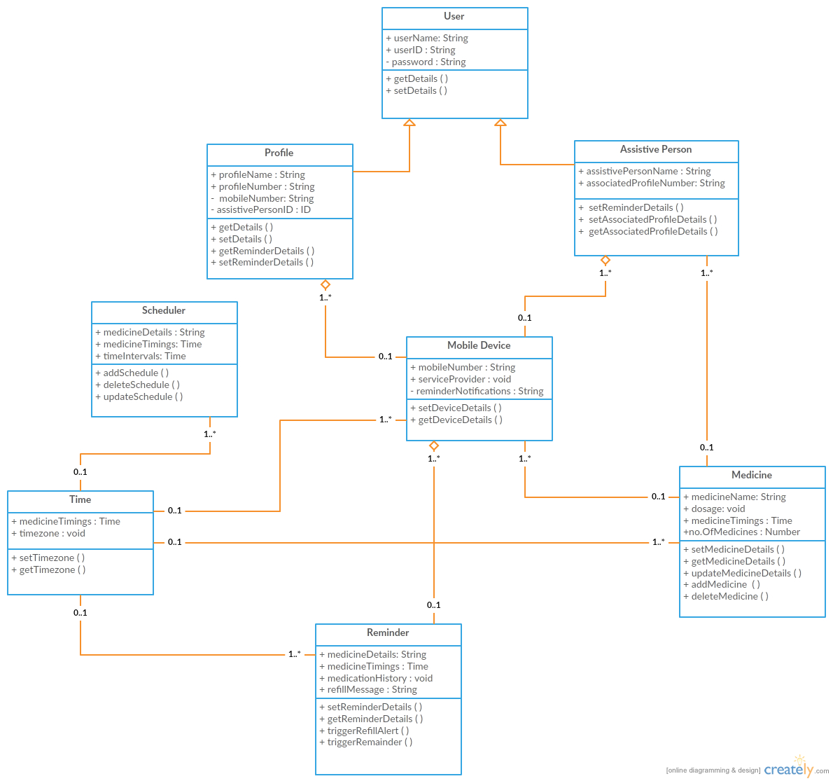

**Activity Diagram:**

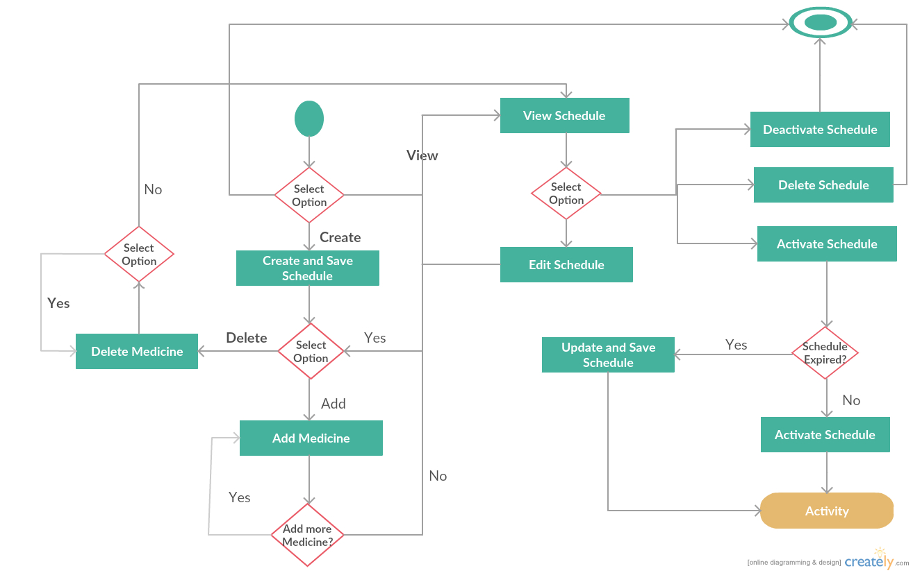

**Sequence Diagram:**

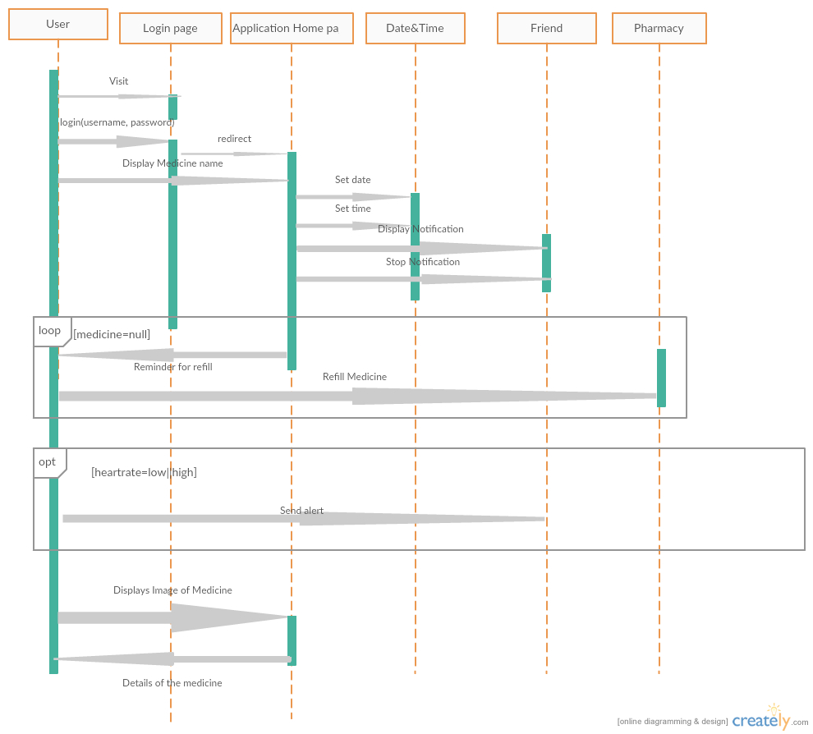

**Architecture Diagram:**

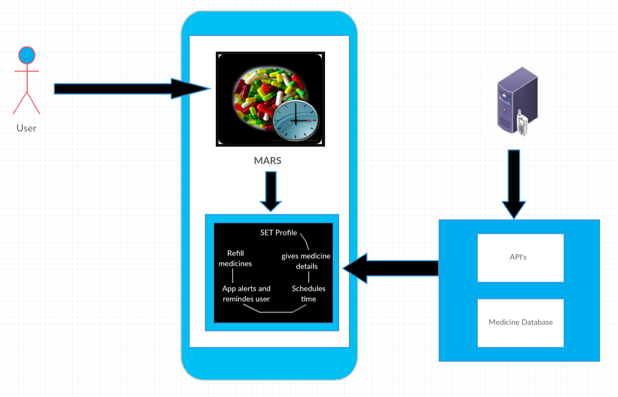

**V.** **Implementation**

**Login Screen in Android:**

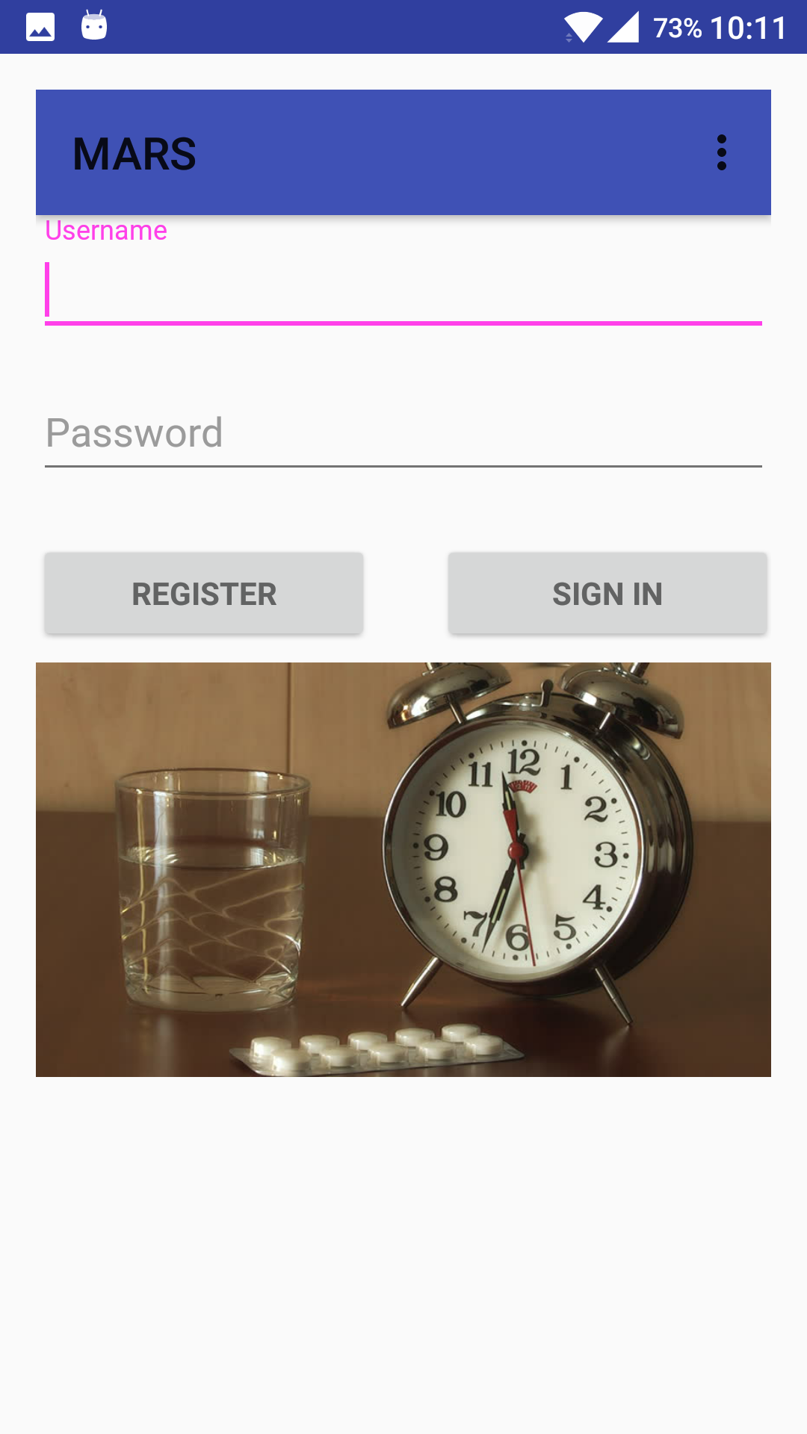

**Login Screen with Settings:**

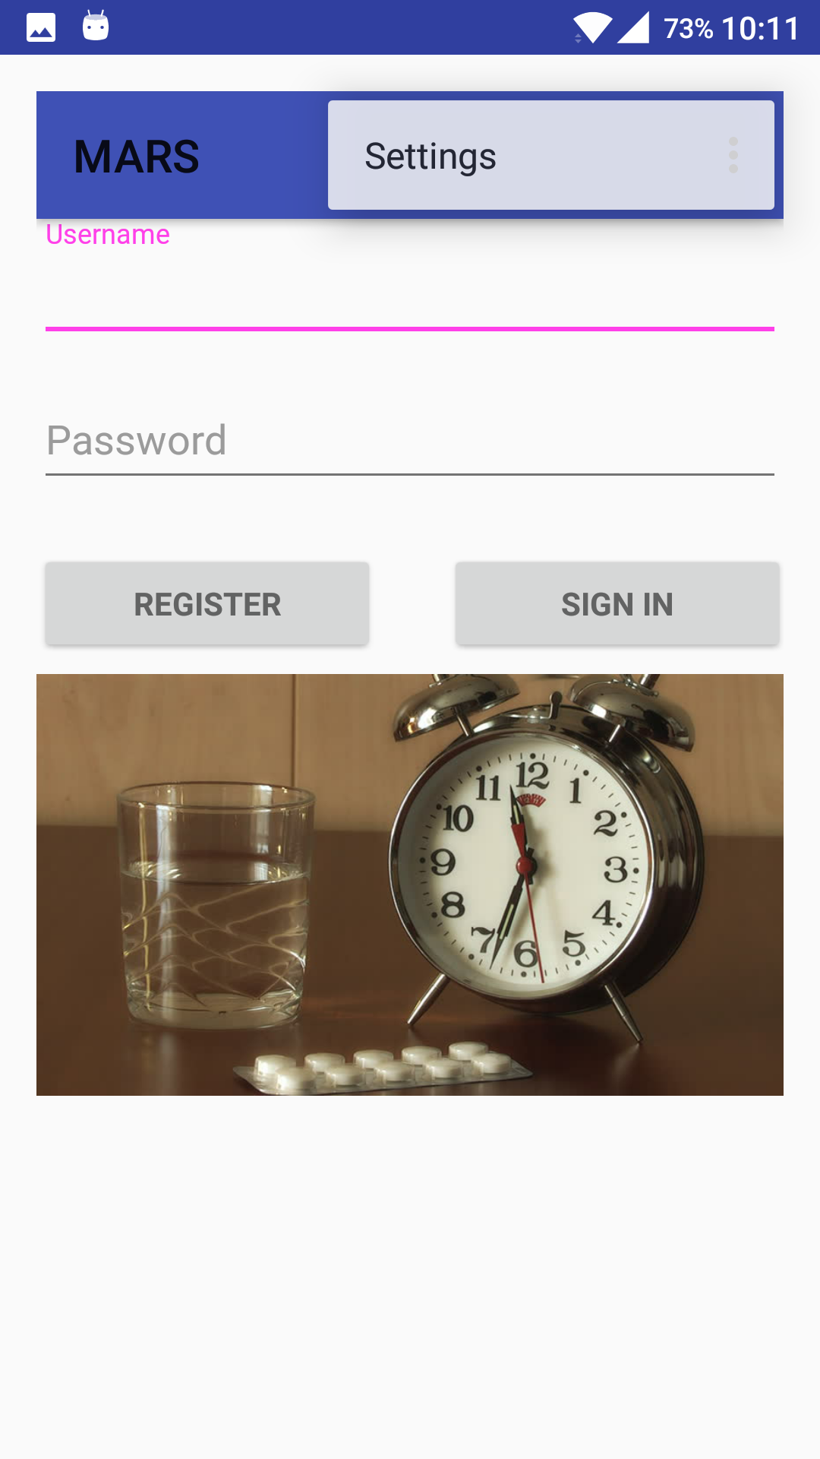

**Registration Screen in Android:**

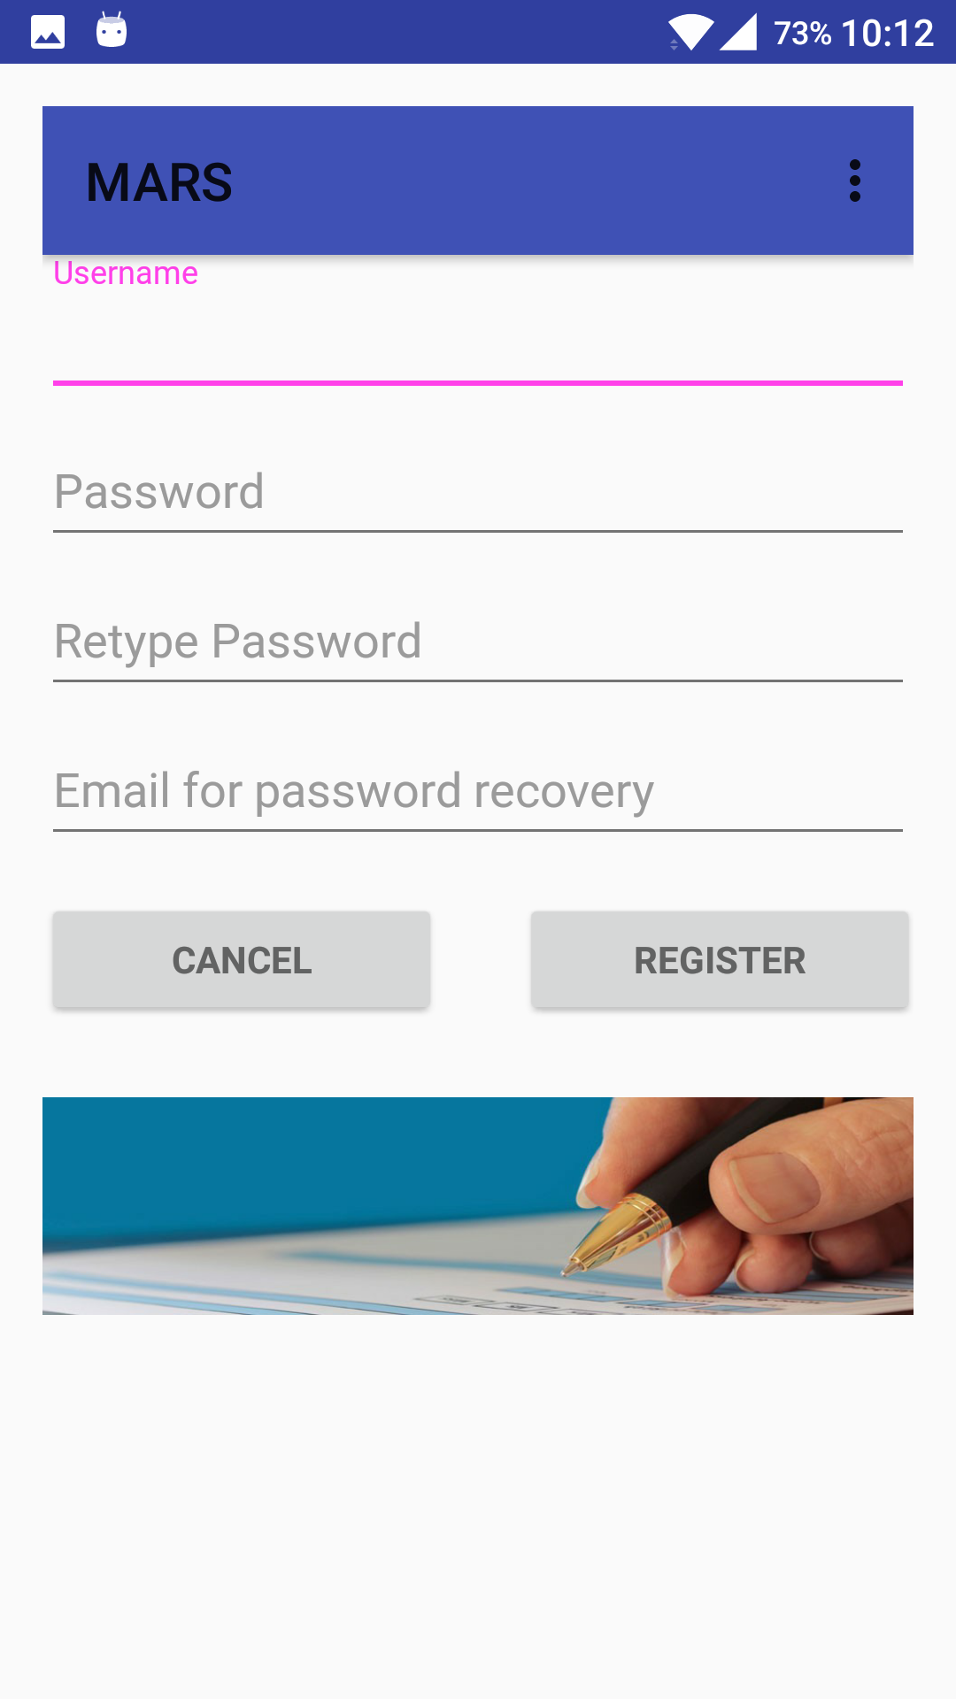

**V.API’s To Be Used**

**IMAGE-TO-TEXT:**

**Cloud Vision API**

Google Cloud Vision API enables developers to understand the content of an image by encapsulating powerful machine learning models in an easy to use REST API. It quickly classifies images into thousands of categories, detects individual objects and faces within images, and finds and reads printed words contained within images.You can build metadata on your image catalog, moderate offensive content, or enable new marketing scenarios through image sentiment analysis. Analyze images uploaded in the request or integrate with your image storage on Google Cloud Storage.

## **Extract Text**

Optical Character Recognition (OCR) enables you to **detect text** within your images, along with **automatic language identification**. Vision API supports a broad set of languages.

**URL:** https://cloud.google.com/vision/

**MEDICINE REFILL:**

# **Walgreens Pharmacy Prescription Refill API**

The Walgreens Pharmacy Prescription API allows users of third-party mobile applications to quickly order refills of prescriptions originally filled at one of the 8,000+ Walgreens pharmacies. Mobile app users can order refills in seconds, as well as select the option to opt-in to receive a text alert when their prescription order is ready for pick up. The health care focused Pharmacy Prescription API is designed to increase prescription compliance and aid in personal health management through automated refill alerts and a streamlining of the refill process. By offering easy prescription refills through this health management API, Walgreens hopes to further increase health care adherence by reaching a wider audience through third party health care apps. So, by using API we can refill the medicines in the medicine box from time-to-time.

**URL:** https://www.programmableweb.com/api/walgreens-pharmacy-prescription-refill

**MEDICINE INFORMATION RETRIEVAL**

## **DailyMed API:**

DailyMed provides high quality information about marketed drugs. This information includes FDA labels. This Web site provides health information providers and the public with a standard, comprehensive, up-to-date, look-up and download resource of medication content and labeling as found in medication package inserts. By using this API we can retrieve information related to a particular medicine.

**URL:** https://www.healthdata.gov/dataset/dailymed

**VI. Testing**

|  |  |  |  |  |
| --- | --- | --- | --- | --- |
| **Sr. No** | **Test Case** | **Description** | **Expected**  **Output** | **Result** |
| 1. | Successful  User Authentication | The user should login with username and password. | Successful Login | Pass |
| 2. | Unsuccessful  User  Authentication | The user logs in with wrong username or password | Login unsuccessful with error-Invalid username or password | Pass |
| 3. | Registration by new user | Admin accepts registration details from the user | Successful registration and transition to Login page | Pass |
| 4. | Invalid Email ID | Invalid Email Id alert. | Error- Enter valid email address | Pass |

**VII.Technologies Used**

**Implementation of Mobile Apps- Technology Used:**

* HTML
* CSS
* Javascript
* Java

**Tools Used:**

* www.Creately.com
* Android SDK

**VIII. Project Management**

**Assigned issues:**

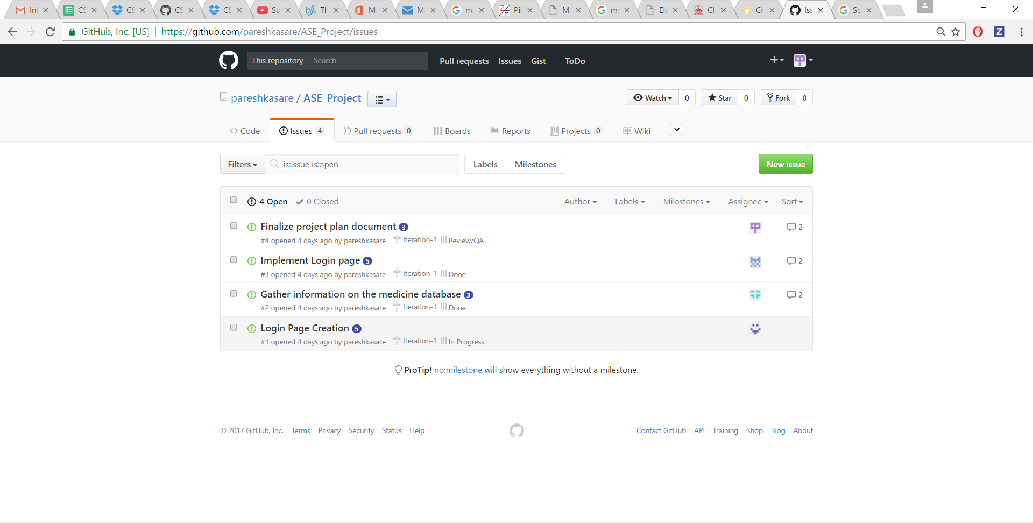

**Issues:**

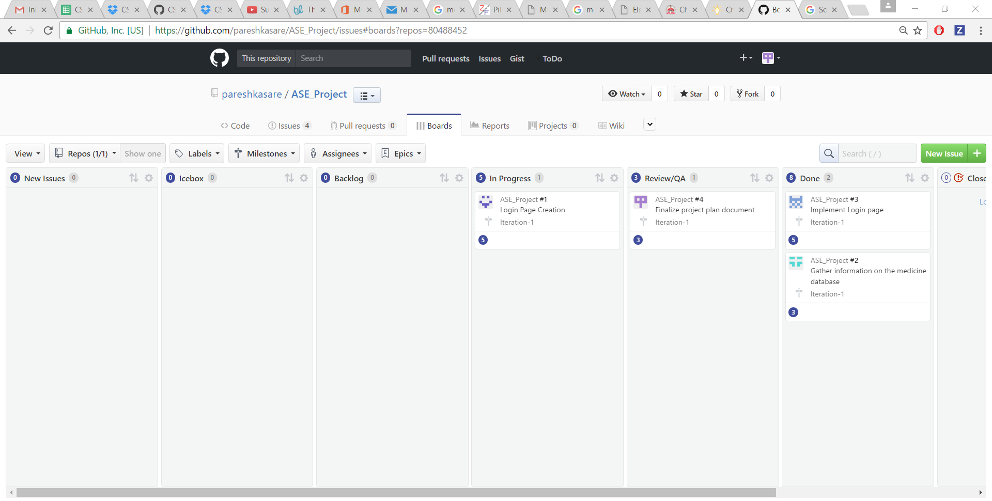

**Closed Issues:**

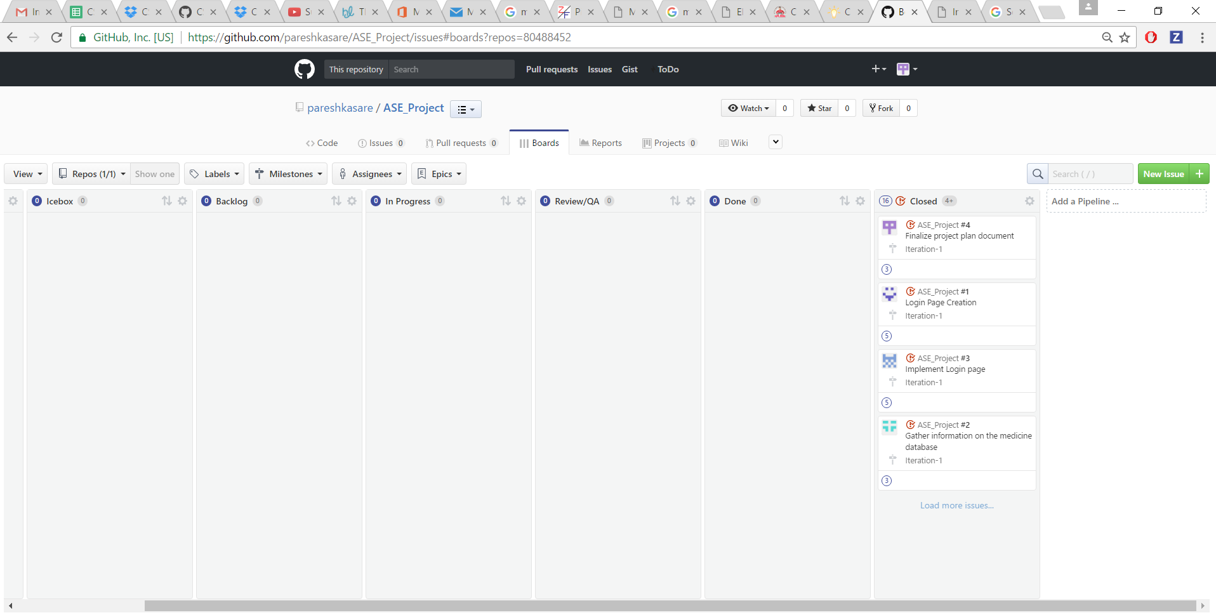

**Burndown Chart:**

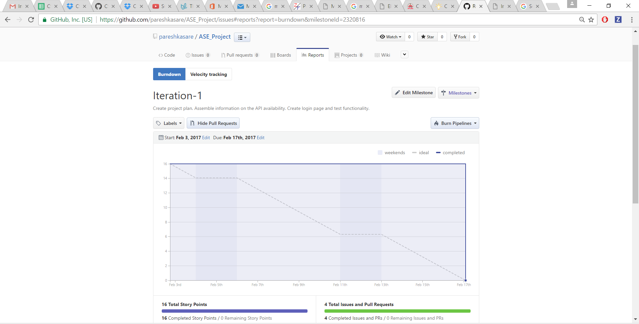

**IX. References**

[**http://www.fda.gov/Drugs/ResourcesForYou/SpecialFeatures/ucm485545.htm**](http://www.fda.gov/Drugs/ResourcesForYou/SpecialFeatures/ucm485545.htm)

[**http://www.fda.gov/ForConsumers/ConsumerUpdates/ucm164616.htm**](http://www.fda.gov/ForConsumers/ConsumerUpdates/ucm164616.htm)

[**http://www.pfizer.com/health/senior_health/taking_medicines**](http://www.pfizer.com/health/senior_health/taking_medicines)

**https://cloud.google.com/vision/**

**https://www.programmableweb.com/api/walgreens-pharmacy-prescription-refill**

**https://www.healthdata.gov/dataset/dailymed**